Lab Walkthrough – 4 (2.9.1)

Title: Basic Switch Configuration and End-to-End Connectivity

Addressing Table
Device | Interface | IP Address | Subnet Mask
Class-A | VLAN 1 | 128.107.20.10 | 255.255.255.0
Class-B | VLAN 1 | 128.107.20.15 | 255.255.255.0
Student-1 | NIC | 128.107.20.25 | 255.255.255.0
Student-2 | NIC | 128.107.20.30 | 255.255.255.0

Objective
The objective of this lab was to:
- To configure hostnames and IP addresses on two Cisco IOS switches using the Command Line Interface (CLI).
- To use Cisco IOS commands to control and secure access to device configurations.
- To save the running configuration to NVRAM to ensure settings are retained after reboot.
- To configure two host devices with appropriate static IP addresses.
- To verify end-to-end connectivity between the two PC end devices using ping commands.

Part 1: Set Up the Network Topology

Step 1: Device Placement
The following devices were placed in Cisco Packet Tracer according to the given topology:
- Two Cisco Switches: Class-A and Class-B
- Two PCs: Student-1 and Student-2
The switches were connected, and each PC was connected to its respective switch.
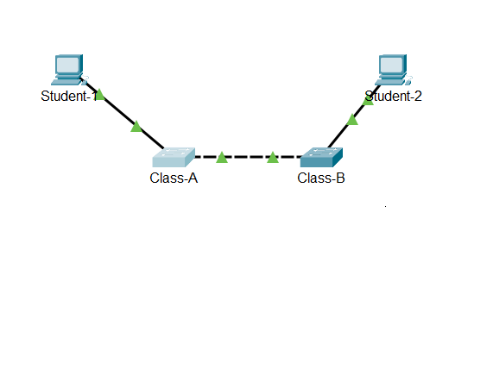

Step 2: Cable Connections
The devices were connected as follows: -
- Class-A FastEthernet0/1 → Class-B FastEthernet0/1 (Copper Crossover Cable)
- Student-1 → Class-A FastEthernet port (Copper Straight-Through Cable)
- Student-2 → Class-B FastEthernet port (Copper Straight-Through Cable)

Console Connection: -
- A Console cable was connected between the PC (RS-232 port) and the Switch Console port to access the switch CLI for configuration.
- Terminal was opened from the PC to configure the switch using Cisco IOS commands.

After connecting: -
- All devices were powered on.
- Link indicators (green triangles) confirmed active physical connections.
- The console session successfully displayed the switch CLI prompt, confirming proper console access.
This matches the provided network diagram and allowed successful configuration and verification of the network devices.
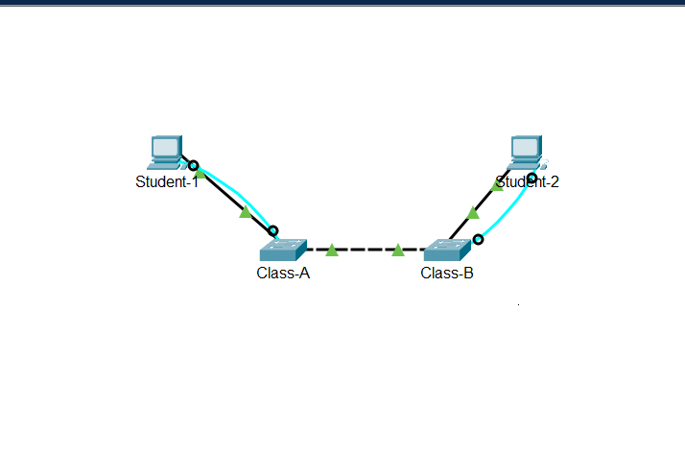

Part 2: Switch Configuration

In Part 2, both switches were configured using console access.
Step 1: Access Switch via Console
- Connected the console cable between the PC and Class-A
- Opened Terminal
- Entered privileged mode using: enable
Each switch was accessed using a console connection via the CLI.

Step 2: Configuration of Class-A
Entered global configuration mode: configure terminal
The following configurations were applied:
- Hostname set to Class-A
- Enable secret password configured as: enable secret 6EBUp
- Console password configured as:
line console 0
password xAw6k
login
exit
- VTY password configured as:
line vty 0 15
password xAw6k
login
exit
- VLAN 1 interface assigned IP address:
interface vlan 1
ip address 128.107.20.10 255.255.255.0
no shutdown
exit
- Password encryption enabled: service password-encryption
- MOTD banner configured: banner motd # Unauthorized access is prohibited #
- Save Configuration:
end
copy running-config startup-config
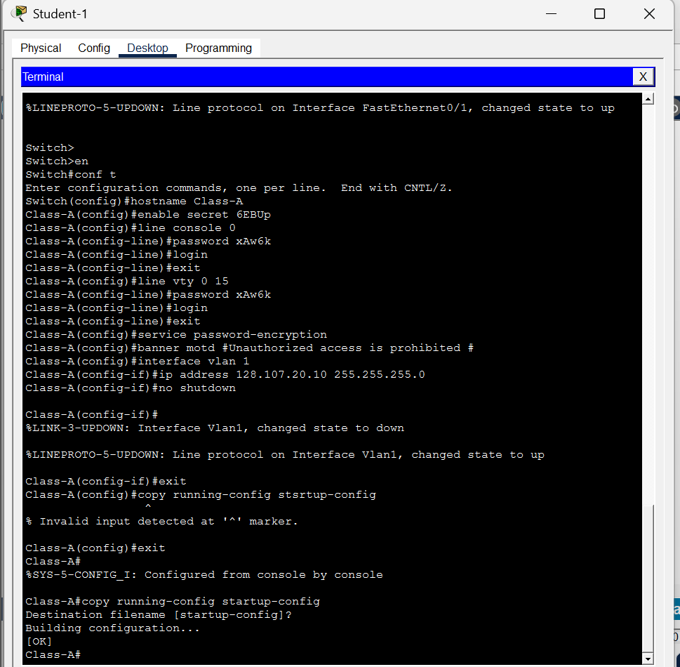

Step 3: Configure Class-B
The same steps were repeated for Class-B with the following changes:
- Hostname set to Class-B
- VLAN 1 IP address configured as: 128.107.20.15 255.255.255.0
- Configuration was saved to NVRAM.

password xAw6k
login
exit
- Password encryption: service password-encryption
- MOTD banner: banner motd # Unauthorized access is prohibited #
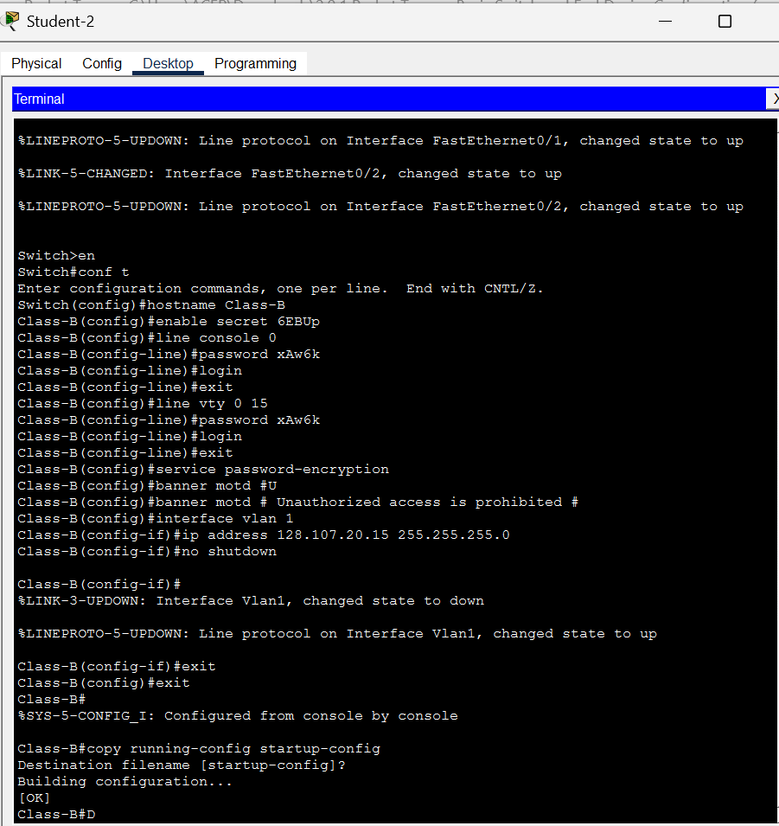

Step 4: Saving Configuration
To ensure the configuration was not lost after reboot, the following command was used:
copy running-config startup-config
Configuration was successfully saved on both switches.
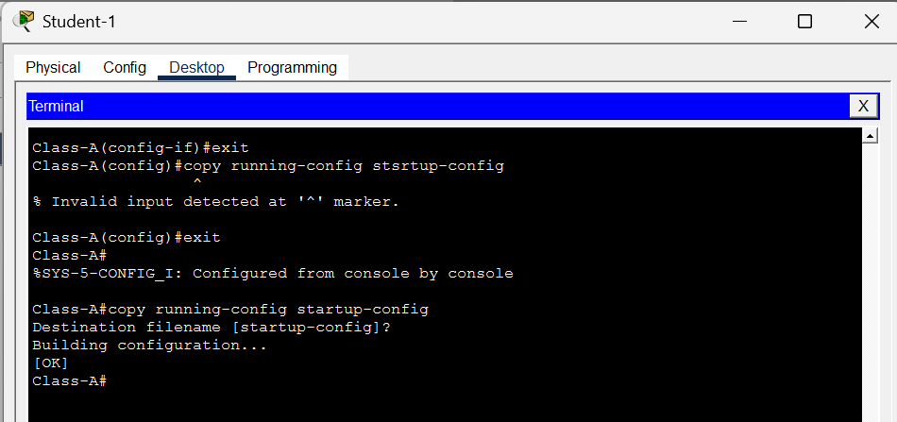
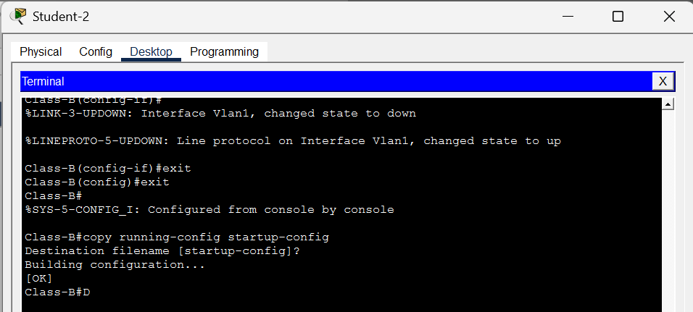

Part 3: PC Hosts Configuration
Both PCs were configured manually using static IP addressing: -

Student-1 Configuration:
- IP Address: 128.107.20.25
- Subnet Mask: 255.255.255.0
- Default Gateway: Not required for this lab
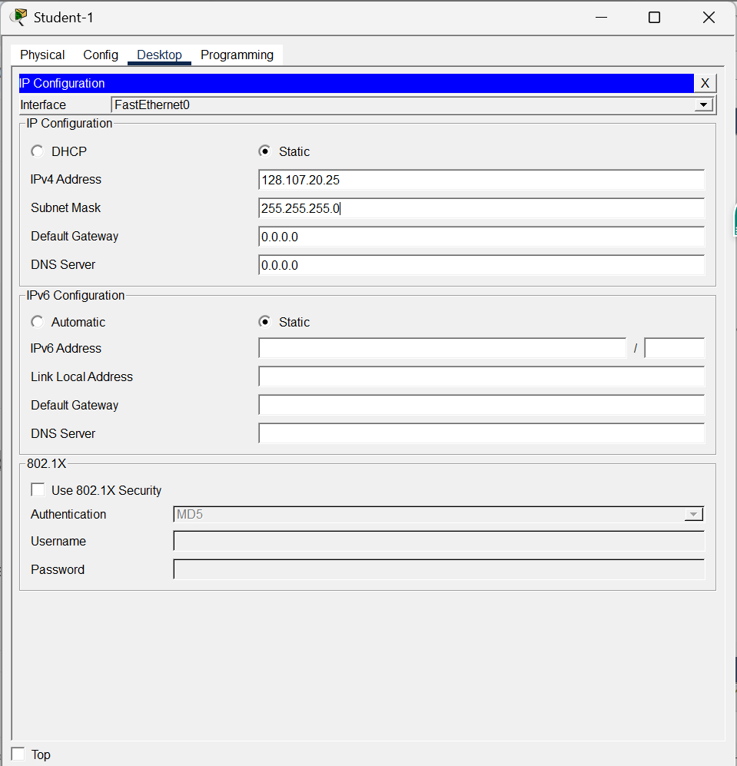
Student-2 Configuration:
- IP Address: 128.107.20.30
- Subnet Mask: 255.255.255.0
- Default Gateway: Not required for this lab
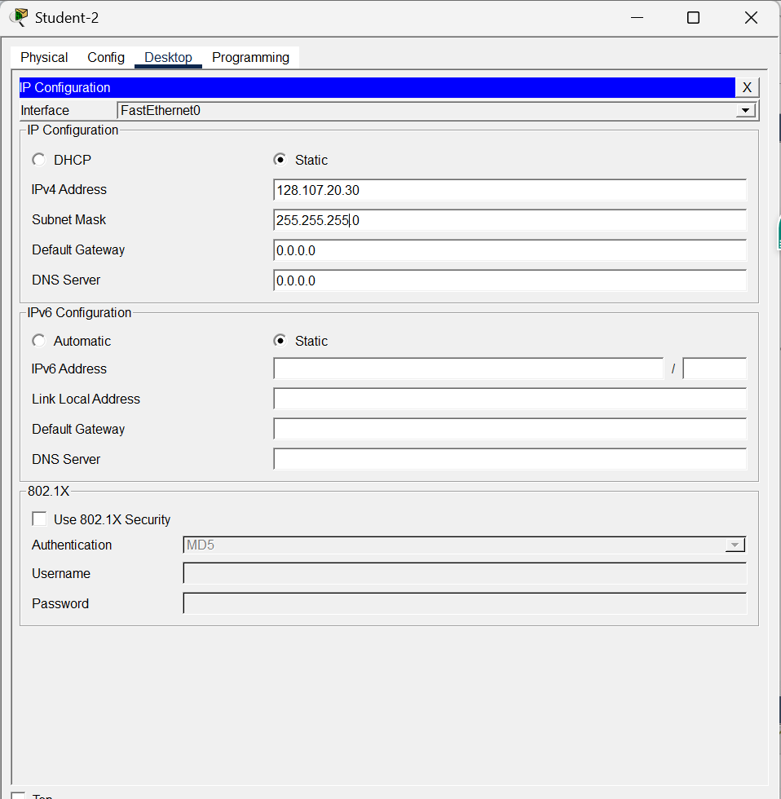
Both PCs were placed in the same /24 network.

Part 4: Connectivity Testing
Connectivity was verified using the ping command.
From Student-1 Command Prompt: ping 128.107.20.30
Successful replies were received, confirming:
- Proper switch configuration
- Correct IP addressing
- Active physical connections
- End-to-end Layer 2 connectivity
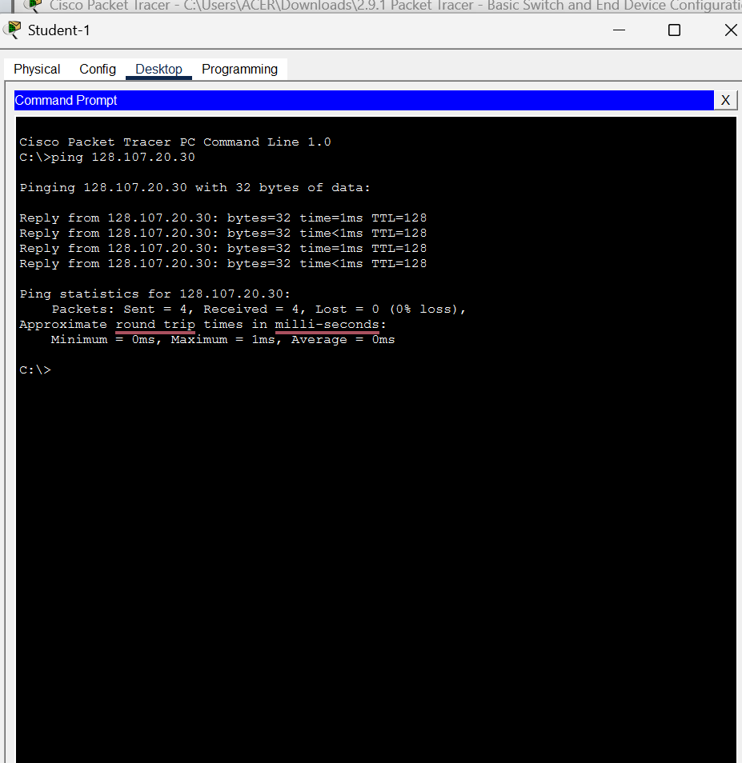
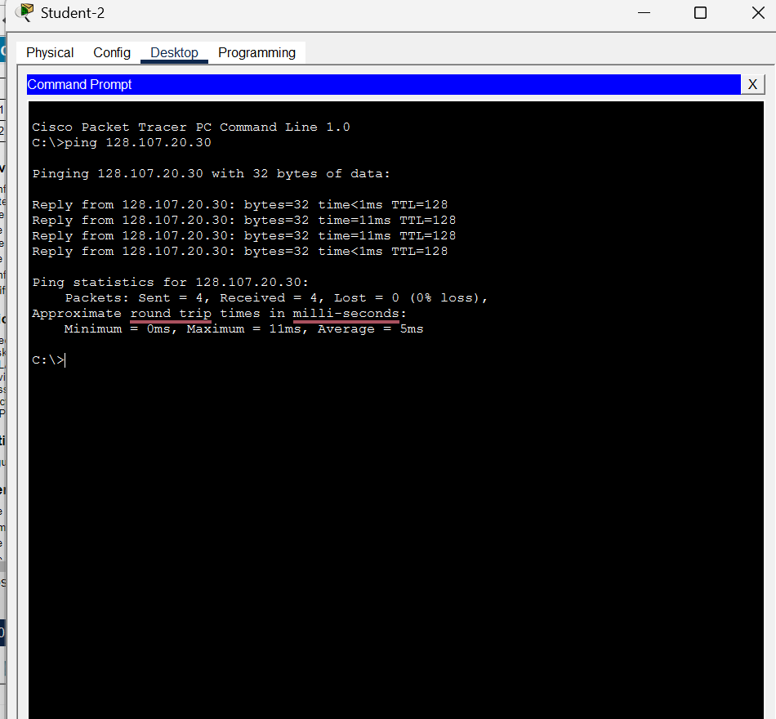

Conclusion
This lab provided a practical understanding of:
- Physical topology configuration
- Static IP addressing
- Basic switch security configuration
- VLAN interface configuration
- Password encryption
- Connectivity verification
- Saving configuration to NVRAM
The lab was completed successfully. This demonstrates the correct implementation of basic switch configuration and LAN connectivity using Cisco IOS.

